Europe’s top young packaging designers honoured in Istanbul

19 SEPTEMBER, ISTANBUL: The 2025 winners of the Pro Carton Young Designers Award (PCYDA) were celebrated on 18 September 2025 at the Awards Gala, held in Istanbul, Türkiye.
As Europe’s leading annual competition for young talent in packaging design, the PCYDA once again shone a spotlight on innovation and sustainability. With a record-breaking number of entries, this year’s awards saw over 950 projects from 102 universities. Each year the competition offers students the chance to gain invaluable real-world experience, explore career opportunities, and win memorable prizes.
The winners were determined by a panel of industry experts and professionals, representative of the entire cartonboard value chain, including Satkar Giddar (Marketing and Branding Consultant), Sanjeev Das (Unilever), Lotte Krekels (Carrefour), Heidi Vanspauwen (Van Genechten Packaging), and Jens Uhlmann (MM Packaging).

Next-generation winners
Hungarian student, Barnabás Varga, from the University of Pécs won the top honours in the Creative Cartonboard Packaging - Food & Drink category with his design Frosty Blaze.
Guided by lecturer Lotte Budai, Barnabás developed a packaging concept that reimagines a Tyrolean classic liqueur. The design preserves the product’s strong character, whilst refreshing its visual identity with a more modern, refined look. To elevate the consumer experience, the gift box also includes two shot glasses, enhancing both its practicality and appeal as a premium gift item.

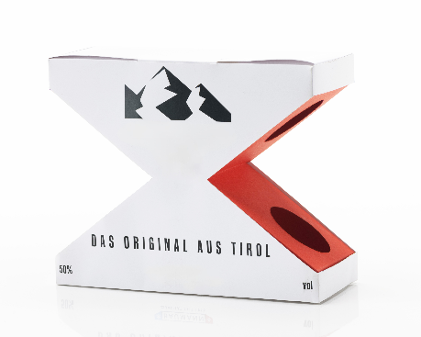
Frosty Blaz by Barnabás Varga- University of Pécs

German students Jule Schelletter, Meret Fischmann, Birte Müller, and Bahareh Hosseinzadeh Alamdari from the MSD - Münster School of Design took the coveted win in the Creative Cartonboard Packaging - All Other category with their innovative design, Padon Period Pads.
Under the leadership of Professor Steffen Schulz, the group created their project with both practicality and empowerment in mind. Padon rethinks period product packaging to create something functional, thoughtful and sustainable. The design features a flip mechanism, one side discreetly stores used products, while the other reveals new ones. Additionally, the outer box doubles as a sleek dispenser through a simple perforated flap, making it ideal for home use, especially in small bathrooms.

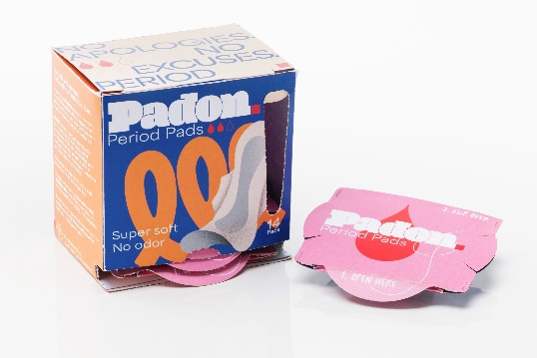
Padon Period Pads by Jule Schelletter, Meret Fischmann, Birte Müller, and Bahareh Hosseinzadeh Alamdari - Münster School of Design
Polish student, Sebastian Jaworski from Politechnika Bydgoska University, claimed the Sustainability Award with his project, Felicia.
Mentored by lecturer Anita Szymankiewicz, Sebastian explored a more sustainable direction for the beauty industry. This alternative cosmetic packaging for glass dropper bottles eliminates plastic while keeping the product secure and communicating key brand messaging. Using significantly less material than conventional cosmetic packaging, the design helps to increase output per production cycle and reduce manufacturing time.

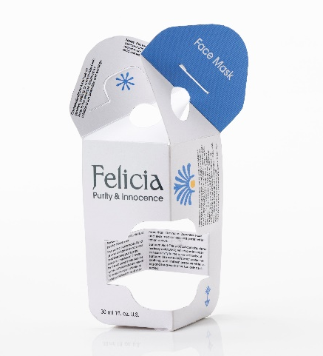
Felicia by Sebastian Jaworski- Politechnika Bydgoska im. Jana i Jędrzeja Śniadeckich

Throughout the summer, the general public, colleagues from the packaging industry, and academics had their say in selecting the Public Award winner for the most impressive next-generation cartonboard concept, with a total of 7,732 votes cast, representing a 9% increase from 2024 figures.
At the 2025 awards in Istanbul, Turkish students Ece Naz Taş, Zeynep Cantürk and Serra Kağıtcı from Middle East Technical University won the Public Award with their innovative design Fold’n’Hold.
Taught by Damla Tönük, the team created Fold’n’Hold, an innovative carrier designed to effortlessly hold four to six drinks with a single, easy motion. Despite its minimalist use of materials, Fold’n’Hold is exceptionally strong, capable of supporting up to 40 times its own weight, combining functionality, sustainability, and thoughtful design in one elegant solution.
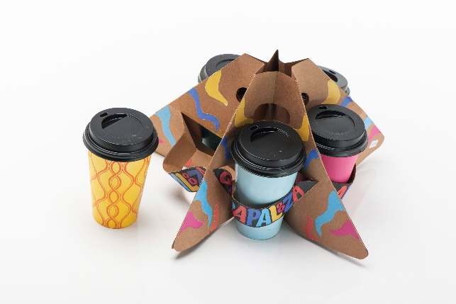
Fold’n’Hold by Ece Naz Taş, Zeynep Cantürk and Serra Kağıtcı - Middle East Technical University

Lastly, an additional recognition, the 2025 Judges’ Award was presented to Romanian student Elena Ghetu from the University of Arts and Design - Cluj-Napoca for the innovative design, Tensum.
With the guidance of lecturer Paul Cheptea, Elena created a new concept for condom packaging that encourages playful interaction with a book-like concept and slots for individual contents. This design is crafted entirely from recycled materials and emphasises that sustainable packaging can be instructional and exciting.

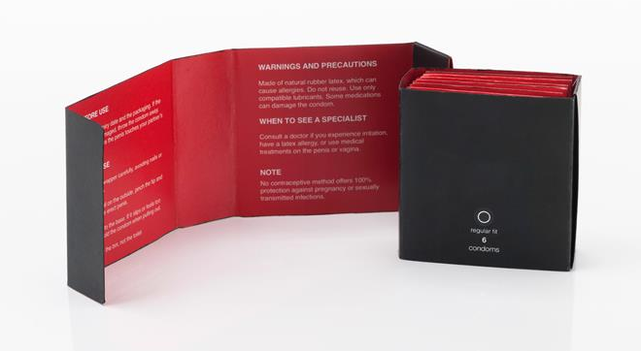
Tensum by Elena Ghetu - University of Arts and Design - Cluj-Napoca
Winfried Muehling, Head of Marketing & Communications at Pro Carton, said: ‘This year’s Pro Carton Young Designers Award has set a new benchmark for creativity and innovation in sustainable packaging. Receiving a new record of 952 entries from 102 universities across Europe is a testament to the growing enthusiasm for sustainable packaging and its potential to inspire smarter and more eco-conscious solutions.
The imagination we have seen from the students is remarkable. Each project reflects a forward-thinking approach that will shape the future of the packaging industry. We congratulate the winners and every participant for their outstanding achievements and can’t wait to see their future contributions to our industry.’

Finalists:
Entry Name | Entrant/s Name | University
Capaging | Alexander Grube | FH Joanneum
diPaScale - a pasta box with a scale | Jovan Berges | Höhere Graphische Bundes-Lehr- und Versuchsanstalt
CLICKFLIP | Simon Dauskardt, Jule Blauert, Louisa Labroisse, and Nele Behrmann | Münster School of Design

The Pro Carton Young Designers Award is sponsored by Van Genechten, FOLBB and Duran Dogan. Additionally, MM Packaging and RDM Group are joint sponsors of the student award programme that Pro Carton hosts, whilst the main prize for this award, the Practical Training Days, are organised by FOLBB and Van Genechten Packaging
For the full list of 2025 winners and finalists, visit here: XXX
-ENDS-
For more information on the benefits of carton and cartonboard, visit www.procarton.com or join the discussion on social media:
Follow Pro Carton on X: www.twitter.com/pro_carton
Like the Pro Carton Facebook page: www.facebook.com/procartoneurope/
Join the discussion on LinkedIn: https://uk.linkedin.com/company/pro-carton
Visit the Pro Carton Pinterest board: www.pinterest.co.uk/procarton/
Notes to editors:
For further information, please contact the Pro Carton press office on +44 (0) 20 7240 2444 or procarton@stormcom.co.uk
About Pro Carton
Pro Carton is the European Association of Carton and Cartonboard manufacturers. Its main purpose is to promote the use of cartons and cartonboard as an economically and ecologically balanced packaging medium. www.procarton.com
What is cartonboard?
Cartonboard is a multilayer paper-based material with, usually, three or more layers of fibre derived from wood, or recycled materials such as paper or cartonboard. It is used in packaging to make cartons for everyday products, such as breakfast cereals, frozen foods, luxury fragrances and pharmaceuticals.

