Pro Carton Student Video Award 2025 honours outstanding storytelling
19 SEPTMEBER 2025, ISTANBUL: The winners of the Pro Carton Student Video Award 2025 (PCSVA), which celebrates the most creative and impactful short films on the benefits of cartonboard, were unveiled on 18 September 2025 during the Awards Gala, held this year in Istanbul, Türkiye.
Now in its sixth year, the PCSVA continues to grow in scope and ambition, welcoming entries from across Europe and drawing on a wide range of filmmaking techniques and storytelling styles. This year’s submissions impressed judges Bady Minck (Award-Winning Film Producer), Simon Bolton (Head Judge & Advertising Consultant), Suhan Gurer (PCSVA sponsor Metpack) and Winfried Muehling (Pro Carton) with their emotional depth, environmental focus and inventive use of cartonboard as a central storytelling element.
This year’s PCSVA Winner is ‘Recycled Romance’, created by Marlene Staak, Leyla Coburger, and Josephine Gosta Gerke from SRH University of Applied Sciences Berlin. The video tells the tale of two characters who communicate solely through cartonboard. With messages handwritten on cartonboard signs, the film explores connection, sustainability and creativity without a single spoken line.
The creators were inspired by the idea that cartonboard is more than just packaging, it’s a carrier of emotion and ideas. By centring cartonboard as the primary mode of communication, the film showcases the material’s potential to foster human connection and reflect deeper environmental values.

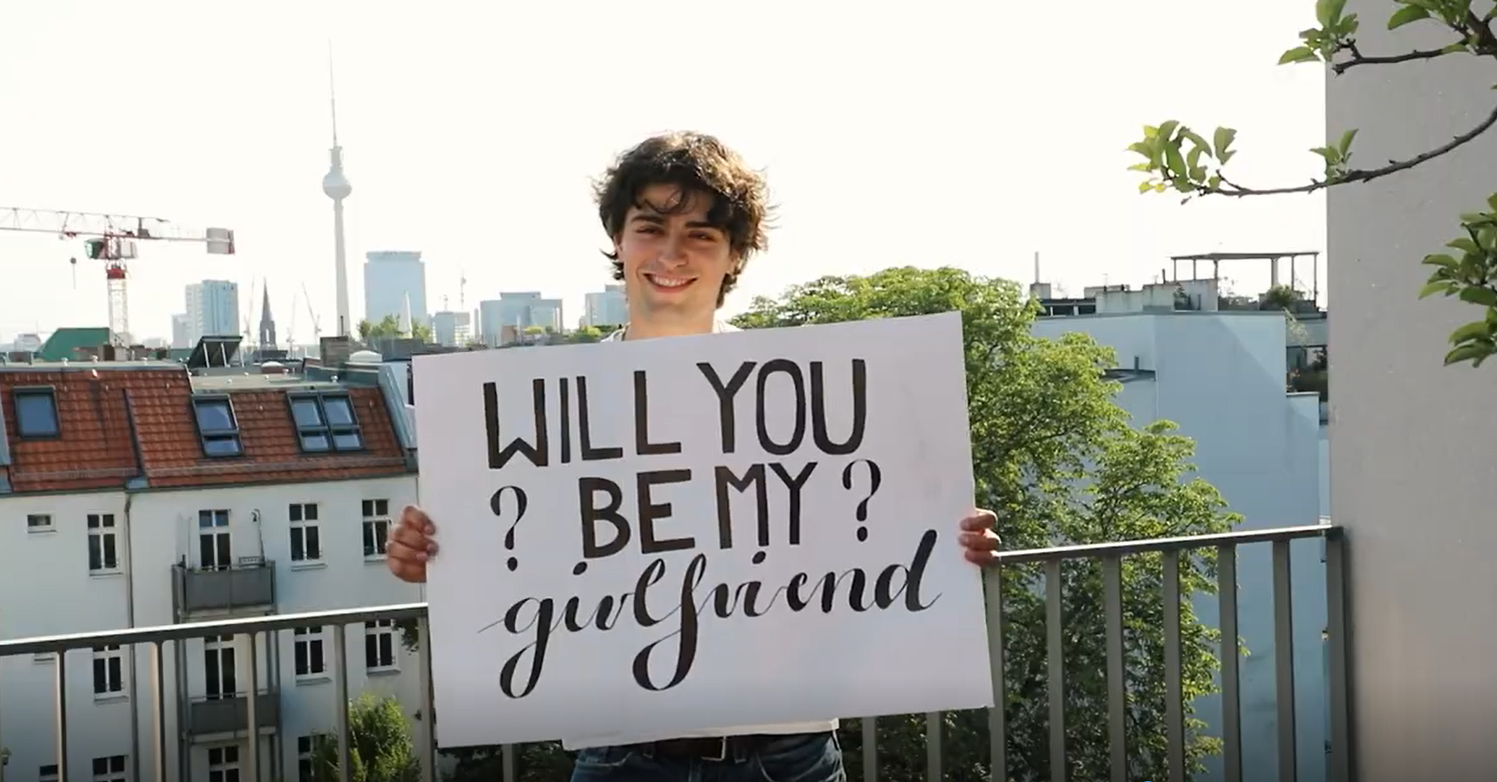
‘Recycled Romance,’ by Marlene Staak, Leyla Coburger, and Josephine Gosta Gerke - SRH University of Applied Sciences Berlin

The Public Award was decided by an open vote over the summer months, giving everyone - from consumers to industry colleagues and academics a chance to have their say. This year, over 2,700 votes were cast, a 48% increase on the 2024 voting period.
This year’s Public Vote winner is ‘Fold’n’Hold’ created by Ece Naz Taş, Zeynep Cantürk and Serra Kağıtcı from Middle East Technical University. The video demonstrates the capability of a strong drink's carrier in different environments, designed to effortlessly hold four to six drinks with a single, easy motion and offers a practical, sustainable solution for consumers and businesses alike.
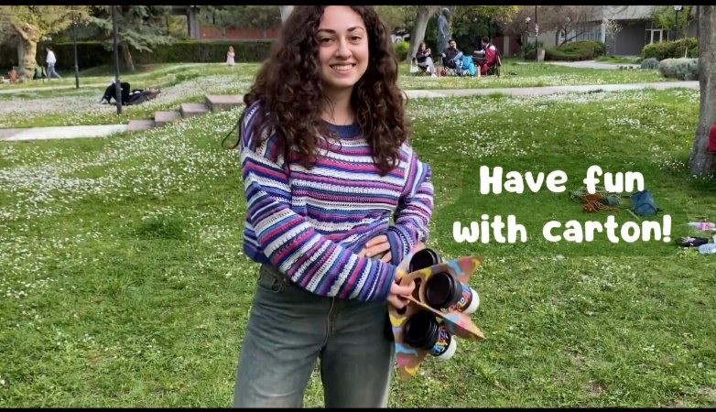
‘Fold’n’Hold’ by Ece Naz Taş, Zeynep Cantürk and Serra Kağıtcı - Middle East Technical University

The 2025 Highly Commended video was awarded to ‘Boyfriend Material’, created by Raphael Wischniewski, Charlotte Anastasia Kabitsyna, Patrick Põldar and John Ojajuni from SRH University of Applied Sciences Berlin. ‘Boyfriend Material’ is a high school story with an eco-conscious twist. Through its heartwarming narrative, the film explores the idea that kindness, empathy and environmental awareness matter more than flashy appearances.
The film cleverly contrasts two potential prom dates: one representing wasteful convenience and the other embodying thoughtful sustainability. The entry explores the current problems of unsustainable packaging and highlights what makes cartonboard so important and versatile as a packaging medium. United by their mutual interest in the environment and sustainable packaging, the protagonist chooses the prom date who truly cares about her, and the environment.

‘Boyfriend Material’, by Raphael Wischniewski, Charlotte Anastasia Kabitsyna, Patrick Põldar and John Ojajuni - SRH University of Applied Sciences Berlin.

Commended for its efforts, ‘I Made You Flowers’, by Jennifer Posas, Miruna Udrea, Eric Pacurar and Lena Jaksic from SRH University of Applied Sciences Berlin, follows an elderly husband who, unable to continue the tradition of buying flowers for his wife, decides to craft flowers from cartonboard instead. With no dialogue and minimal effects, the video speaks volumes about sustainability, tradition, and the emotional resonance of handmade gifts
Also Commended, ‘Cartonboard Never Dies’, by Julián Cilento, Marc Albertí, Esmeralda Rodríguez, Mireia Pey and Camila Garcia from Salesians Sarrià in Spain. A fun and fast-paced film that illustrates the lifecycle and versatility of cartonboard, with the entire set and props made from cartonboard. The video highlights the recyclability of cartonboard, by demonstrating how a piece of waste can be recycled into a new pair of trainers which, when at the end of their life can be recycled yet again, reminding viewers that the useful life of cartonboard is surprisingly long.
Commenting on this year’s competition, Simon Bolton, Head Judge and board member at EVERLAND, Kontrapunkt and Kapero, said: “The students brought an extraordinary level of innovation to the 2025 competition. Their videos weren’t just educational, they were touching, witty and beautifully produced. Each one reflected a deep understanding of cartonboard’s role in a sustainable future, and we were thrilled to see such emotionally resonant storytelling tied seamlessly to environmental messaging.”
Winfried Muehling, Head of Marketing & Communications at Pro Carton, added: “The Pro Carton Student Video Award continues to inspire and surprise us each year. In 2025, the students showed technical skill and originality, as well as a strong commitment to communicating the values behind cartonboard. These stories help move sustainable packaging from a technical topic to a human one, and that’s how change begins. Each entry was unique, and each student should be incredibly proud of the work they put forward.”
The Pro Carton Student Video Award 2025 is sponsored by Stora Enso, Metpack and Kartonsan Additionally, MM Packaging and RDM Group are joint sponsors of the student award programme hosted by Pro Carton.
For the full list of 2025 PCSVA winners and finalists, visit: XXX
-ENDS-
For more information on the benefits of carton and cartonboard, visit www.procarton.com or join the discussion on social media:
Follow Pro Carton on X: www.twitter.com/pro_carton
Like the Pro Carton Facebook page: www.facebook.com/procartoneurope/
Join the discussion on LinkedIn: https://uk.linkedin.com/company/pro-carton
Visit the Pro Carton Pinterest board: www.pinterest.co.uk/procarton/
Notes to editors:
For further information, please contact the Pro Carton press office on +44 (0) 20 7240 2444 or procarton@stormcom.co.uk
About Pro Carton
Pro Carton is the European Association of Carton and Cartonboard manufacturers. Its main purpose is to promote the use of cartons and cartonboard as an economically and ecologically balanced packaging medium. www.procarton.com
What is cartonboard?
Cartonboard is a multilayer paper-based material with, usually, three or more layers of fibre derived from wood, or recycled materials such as paper or cartonboard. It is used in packaging to make cartons for everyday products, such as breakfast cereals, frozen foods, luxury fragrances and pharmaceuticals.

