Packaging design visionaries take a bow at ECEA 2025 Ceremony
19 SEPTEMBER 2025, ISTANBUL: Celebrating innovation in fibre-based packaging design, the 2025 winners of the European Carton Excellence Award (ECEA) were announced on 18 September during the annual Awards Gala, held at The Peninsula in Istanbul, Türkiye.

Hosted by Pro Carton and the European Carton Makers Association and sponsored by Heidelberger Druckmaschinen AG the ECEA is the longest-standing and most prestigious award for cartonboard and folding carton design, celebrating all value chain members for their extensive contributions to sustainable packaging innovation. Major winners of the night included Van Genechten Packaging, MM Packaging, Graphic Packaging International, Metsä Board, Stora Enso, RDM Group, and Holmen Board and Paper along with several other industry leaders.

The trophy winners spanned four coveted special recognition awards, seven new end-user focused categories and platinum and gold entries. Determined by a distinguished panel of industry experts and representatives across the entire value chain, the judges included Satkar Giddar (Marketing and Branding Consultant), Sanjeev Das (Unilever), and Susanne Lippitsch (Design Consultant).

Top honour recognition

Claiming the industry's highest recognition, Carton of the Year, was carton converter Van Genechten Packaging and cartonboard manufacturer Metsä Board. Their entry, Lumene 24 Nordic Beauty Secrets Advent Calendar, reimagines the traditional Advent Wreath as a hexagonal tray with 24 spiral-arranged puzzle boxes of varying heights for Lumene cosmetic treats. The innovative design features mono-material, FSC-certified construction made entirely from cartonboard, flat-pack delivery for reduced transport emissions, and Nordic-inspired graphics enhanced with translucent holographic foil and 3D embossing while maintaining full recyclability.
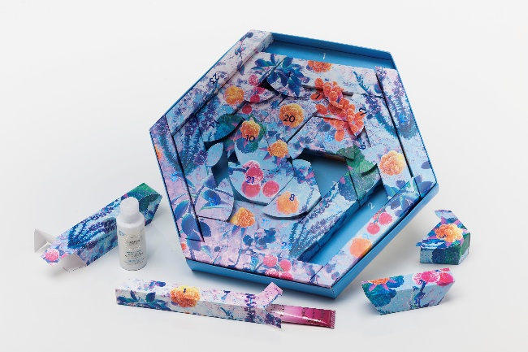
Carton of the Year Winner: Lumene 24 Nordic Beauty Secrets

Receiving the Innovation Award, carton converter and cartonboard manufacturer Graphic Packaging International created the Leffe Beer Multipack featuring groundbreaking Two-Piece Technology to hold 20x 330ml glass bottles. This packaging breakthrough eliminates plastic-reinforced handles in favour of an alternative made from renewable wood-based fibre, with up to 30% recycled cartonboard. The design features an independently reinforced handle that maintains durability while using minimal material, runs efficiently on existing machinery, and delivers superior comfort for carrying. The design also features a detachable barcode to assist the checkout experience for consumers.

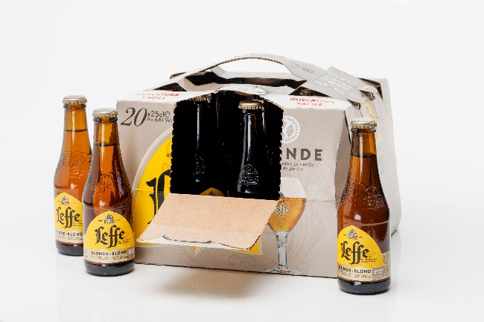
Innovation Award Winner: Leffe Beer Multipack

Securing the Sustainability Award, carton converter Lucaprint S.p.A. and cartonboard manufacturer Stora Enso developed a fully cartonboard packaging solution for Claber's Lancia Pro 8535 hose nozzle. Eliminating plastic and replacing the previous mixed-material format, this innovative mono-material pack reduces packaging volume by 50%. It features integrated locking systems engineered directly into the cartonboard for product stability, maintaining maximum product visibility for a strong shelf impact. Designing bespoke locking mechanisms for each uniquely dimensioned product, while ensuring compatibility with automated production processes, was a challenge. However, the result is a cohesive and recognisable design that is easily identifiable across the entire product range.

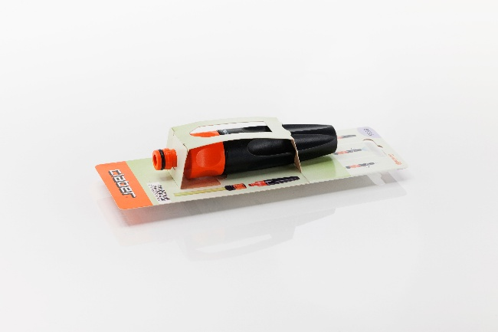
Sustainability Award Winner: Claber Lancia Pro 8535

Over the summer, the wider public, along with colleagues from the packaging industry and academics, cast their votes to decide the Public Award winner for the most impressive ecological cartonboard concept. A total of 7,600 votes were received, compared with 5,956 in 2024.

The exceptional design, the Neuhaus Easter Filled Figures created by DUCAJU and carton manufactured by Holmen Paper and Board secured its place as the 2025 Public Award winner. Designed to appeal to both children and adults, the house-shaped packaging brings together design, sustainable innovation and premium craftsmanship into a food-safe cartonboard solution. The shape evokes a sense of familiarity and celebration, while the clever thumb tab and flap closure ensure the box can be opened and resealed without damage to the five indulgent Easter eggs inside.
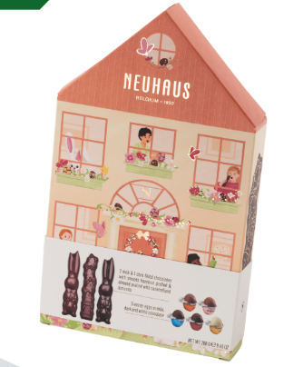
Public Award Winner: Neuhaus Easter Filled Figures

New category champions

For the first time in 2025, the ECEA introduced dedicated category awards recognising excellence across specific market sectors. These new brand-owner-focused categories reflect the diverse applications and specialised requirements of modern cartonboard packaging across different industries.
Food and beverage packaging lead the new categories. The Confectionery Award went to carton converter MM Packaging Polska and cartonboard manufacturer Stora Enso for their innovative Milka Advent Calendar design that combines festive appeal with functional excellence. Ticking the box for interactive shelf display and sophisticated design, carton converter Smurfit Westrock and cartonboard manufacturer Holmen Board and Paper won the Beverages Award with their Hine Ball Cognac packaging. Van Genechten Packaging proved their versatility by securing two food category wins, partnering with cartonboard manufacturer RDM Group for the Ambient Food Award with the recycled material Cassegrain Pack 3x1/2 multi-pack that securely packages upright 3-can bundle. The converter also collaborated with cartonboard manufacturer Stora Enso to claim the Chilled & Frozen Food Award for the PAVÉ D'AFFINOIS Mini l'Original 4x30gr packaging, showcasing a sustainable switch to fibre-based packaging from the previous multi-material formats used to package mini cheese.

Carton converter PAWI Packaging Deutschland GmbH and cartonboard manufacturer Holmen Board and Paper won the Pharma & Health Care Award with their Phonak Hearing Aids design, successfully balancing product protection with user accessibility. Meanwhile, the Beauty & Cosmetics Award recognised the elegant Rituals Car Gift Set Sakura by carton converter Van Genechten Packaging and cartonboard manufacturer Stora Enso, which enhances the premium brand experience through thoughtful presentation and a secure internal locking system to eliminate spills and seals.

The General Packaging Award rounded out the evening, with carton converter Cosack GmbH & Co. KG Druck + Verpackung and cartonboard manufacturer Smurfit WestRock demonstrating effective product presentation and protection for the Friedr. Herder Abr. Sohn GmbH Vegetable Knife packaging.

Winfried Muehling, Pro Carton’s Marketing and Communications Director, commented: “I want to extend a huge congratulations to all the winners and finalists. All entries this year demonstrated that eco-friendly packaging isn’t a trade-off but a testament to what’s possible when innovation meets sustainability. From clever multipacks to beautifully crafted advent calendars, the fibre-based solutions we saw prove that protecting the planet and creating standout consumer experiences can go hand in hand. It’s also incredibly encouraging to see more brand owners embracing fibre-based packaging, not just as a sustainable choice but as a strategic one that drives design, function, and impact on shelf.”

This year’s ECEA was sponsored by Heidelberger Druckmaschinen AG.

Find the full list of winners and finalists on the Pro Carton website, here.

Ends

